Playing with CircuitBreaker Resilience4J feature

Lets play with circuit breaker now ;

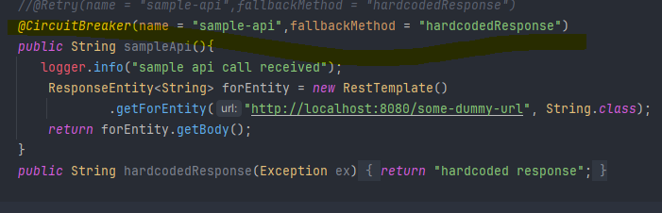

**Run below command in powershell**

for ($i=1; $i -le 20; $i++) {curl http://localhost:8002/sample-api}



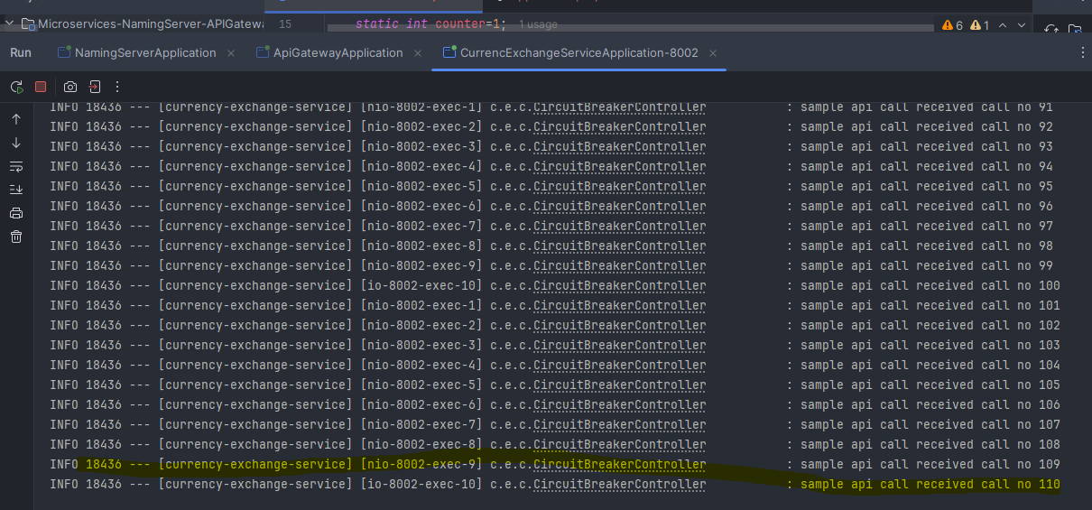

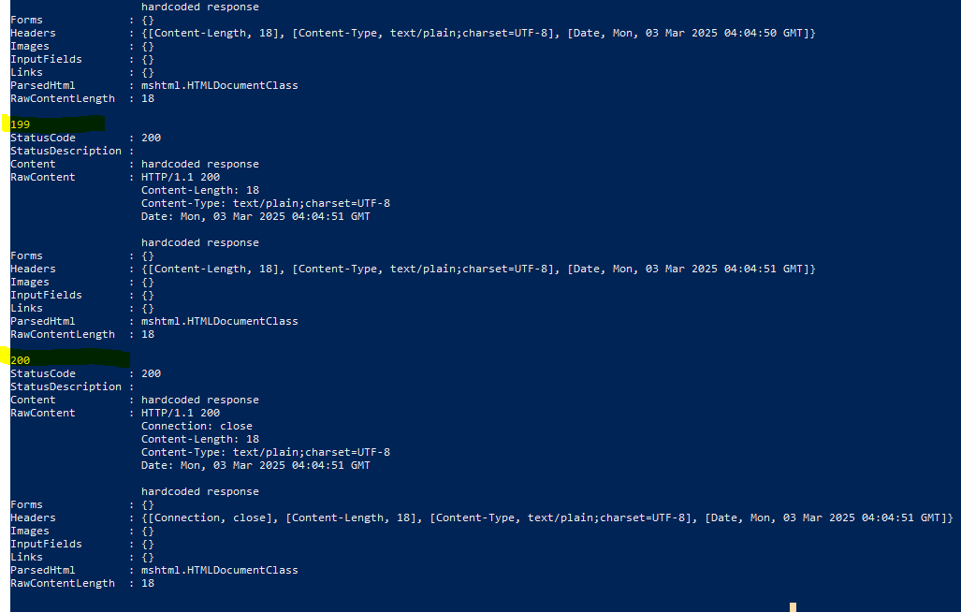

https://resilience4j.readme.io/docs/circuitbreaker